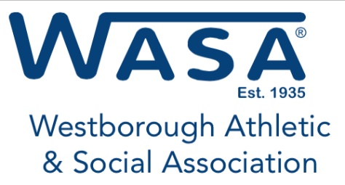
Returning College Sophomore Application
Deadline for Filing is July 31, 2023
Application pertains to students entering into the second year of an accredited two or four year college. Please Print or Type the information / data
Date: _____________
Student Information
Full Name: | Email address:
Home Address: | Phone #
Father: | Occupation:
Mother: | Occupation:
Family members attending college next year
(number only):
Expected college expenses
Tuition: $ | Room and Board: $
Books and Lab Fees: $ | Transportation: $
 | Total Expenses: $

Family Gross Income Level | Check appropriate
Below $50,000 | ☐
$50 - $100K | ☐
$100K - $150K | ☐
$150K - $200K | ☐
$200 - $300K | ☐
$300K + | ☐

Have you worked while attending college? Yes ☐ No ☐
If yes please explain type of work experiences:
Company Name | Job Description

Please list other scholarships or financial assistance you are receiving including specific dollar amounts:
Name | Amount

Please list any additional factor(s) or financial considerations that will assist the WASA Scholarship Committee in weighing your situation to determine your qualification for this scholarship assistance. Please include all community service work and projects.

** Please include a copy of present grades / marks from the college you attended as a Freshman
Have you participated in sports in High School or College? Yes ☐ No ☐
List High School Sports activities: _____________________________________________________________________
List College Sports activities:
_____________________________________________________________________

Applicant’s signature |  | Date
Father/Guardian signature |  | Date
Mother/Guardian signature |  | Date

BE ASSURED THAT ALL THE ABOVE INFORMATION IS STRICTLY CONFIDENTIAL
Please return to:
Westborough Athletic and Social Association
P.O. Box 165
Westborough, MA 01581
Attn: Scholarship Committee

